Software Requirements Specification

For

eBook Management System

Version 2.2

Prepared by : Muhammad Shayan (2023F-BSE-088)
Suhaib (2023F-BSE-063)
Muhammad Ezaan (2023F-BSE-081)
Muhammad Shahzil (2023F-BSE-327)

Introduction to Software Engineering (SSUET)

Date: 11-07-2024

Table of Contents:

1. Introduction ………………………………………………………………………………………………………………….01
1.1 Purpose
1.2 Scope
1.3 Definitions, Acronyms, and Abbreviations
1.4 References
2. Existence Background of the Project ……………………………………………………………….02
3. Tools Used ………………………………………………………………………………………………………………….02
4. Technical Requirements Needed ……………………………………………………………………….02
5. Gantt Chart …………………………………………………………………………………………………………………03
6. Network Diagram …………………………………………………………………………………………………….04
7. Complete Source Code …………………………………………………………………………………………..05
8. Complete Project Snapshot with Outputs ……………………………………………………….23
9. Flowchart Diagram ………………………………………………………………………………………………….28
10. Use Case Diagram ..…………………………………………………………………………………………………29
11. Class Diagram .………………………………………………………………………………………………………….30
12. Sequence Diagram .…………………………………………………………………………………………………31
13. Entity Relationship Diagram .……………………………………………………………………………….32
14. Data Flow Diagram ………………………………………………………………………………………………….33
15. Conclusion ………………………………………………………………………………………………………………….34
1. Introduction:
1.1 Purpose :
The purpose of this project is to develop an eBook Management System (EMS) that simplifies and automates the management of library resources. This system aims to provide efficient management of book inventory, streamline the process of book borrowing and returning, and enhance user access to library services. The EMS is intended to replace manual, paper-based processes with a digital solution that improves accuracy, accessibility, and productivity within the library environment.

1.2 Scope :
This SRS document outlines the requirements for an eBook Management System using Java Swing for the GUI. The system will manage eBooks, student registrations, and the processes of issuing and returning books efficiently. The homepage will feature six windows: New Book, Statistics, New Student, Issue Book, Return Book, and About.

1.3 Definitions, Acronyms, and Abbreviations :
- SRS : Software Requirements Specification
- GUI : Graphical User Interface
- UML : Unified Modeling Language

1.4 References :
Java Documentation: Official Java Documentation. Link
SQLite Documentation: Official SQLite Documentation. Link

2. Existence Background of the Project :
Traditional management of physical books in educational institutions often results in delays, errors, and inefficiencies. This project addresses these issues by implementing a digital eBook Management System. The primary objective is to provide a smooth and efficient way for managing eBooks, ensuring that students and staff can access and manage eBooks without any hassle.
3. Tools Used :
- Java: A high-level, object-oriented programming language used for developing the application's front-end and business logic. Java's platform independence ensures the EMS can run on multiple operating systems.
- Library: Swing and JFrame.
- SQLite: A lightweight, serverless, self-contained SQL database engine used for storing library data. It is integrated into the application, providing a robust yet simple database solution.
- Apache NetBeans IDE: An integrated development environment used for coding and debugging the Java application. It provides tools for project management, code editing, and refactoring, offering a user-friendly interface and extensive plugin support for enhanced productivity.
4. Technical Requirements Needed (Hardware) :
- Server : AMD Ryzen 5, 16GB RAM, 500GB SDD.
- Client Workstations : Intel Core i5, 4GB RAM, 256GB HDD.
- Network Devices : Router, Switches.
- Tablets for Students : Any Android or iOS tablet.

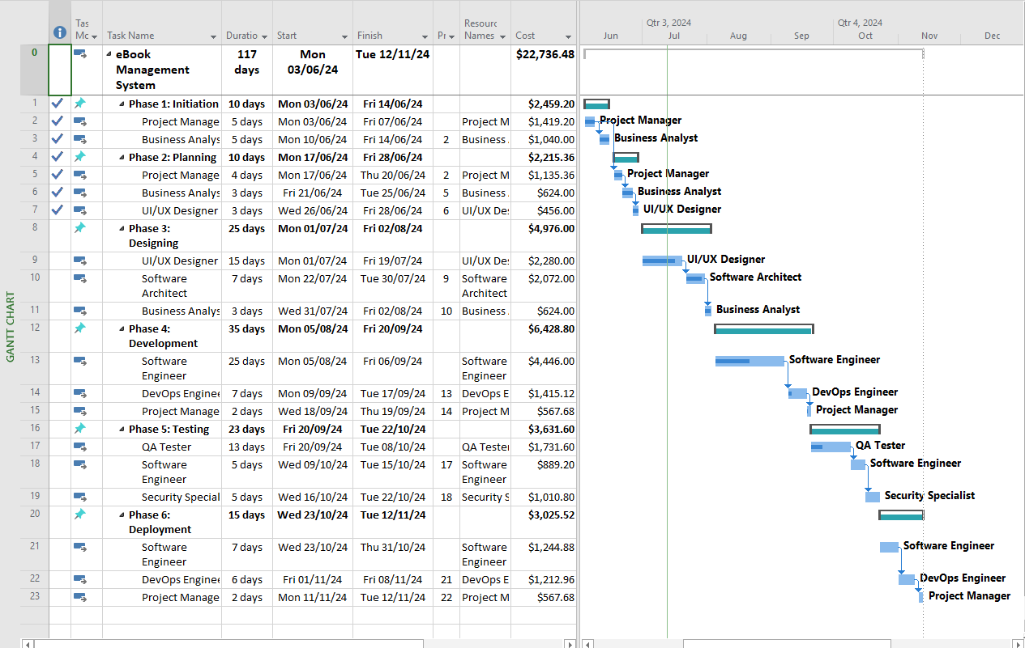
5. Gantt Chart :

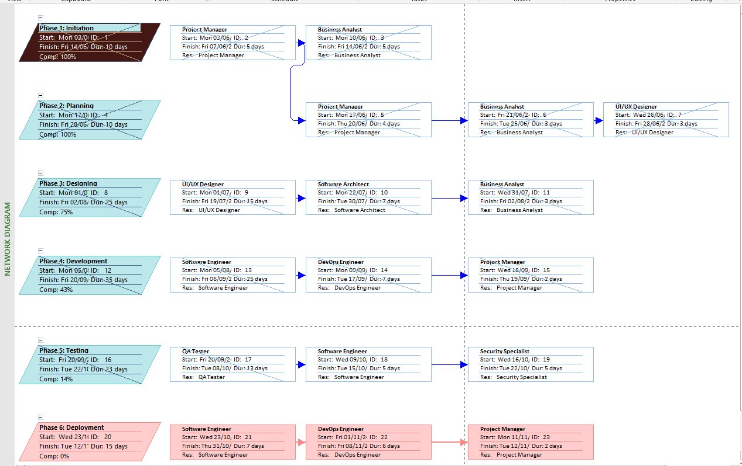
6. Network Diagram :

7. Complete Source Code : Login.Java
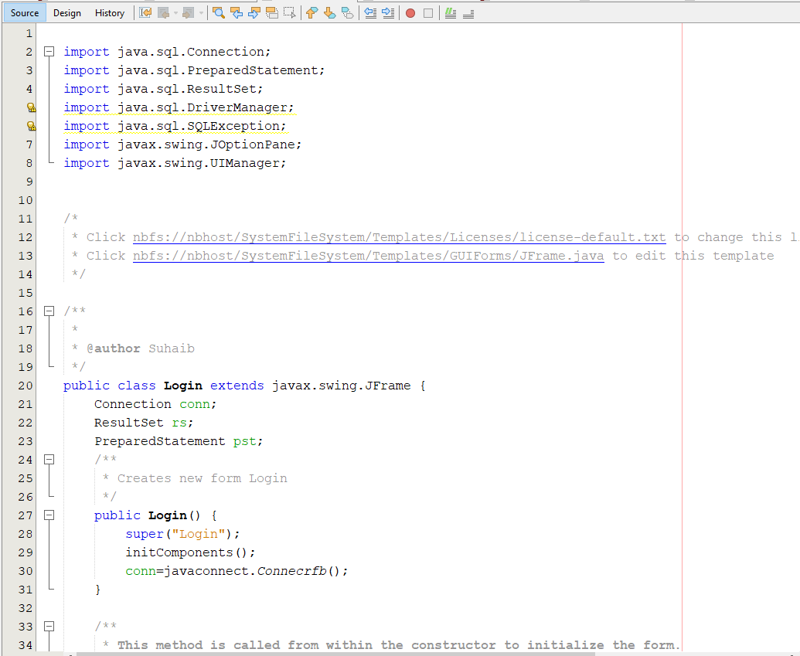
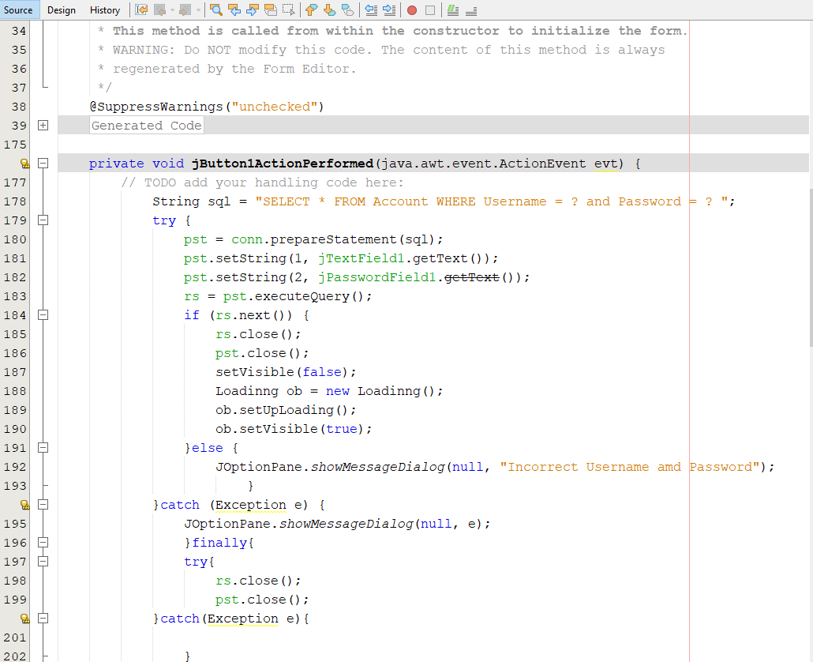
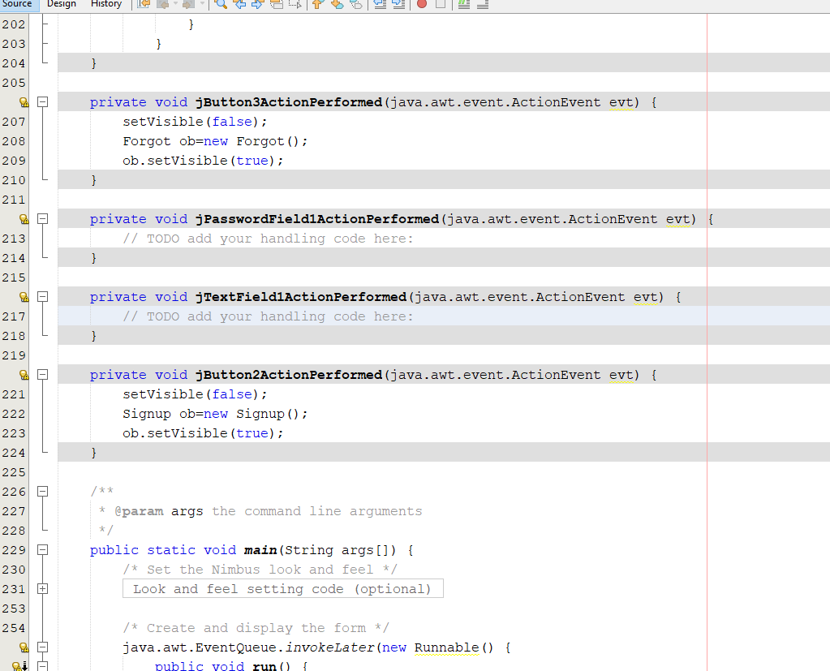
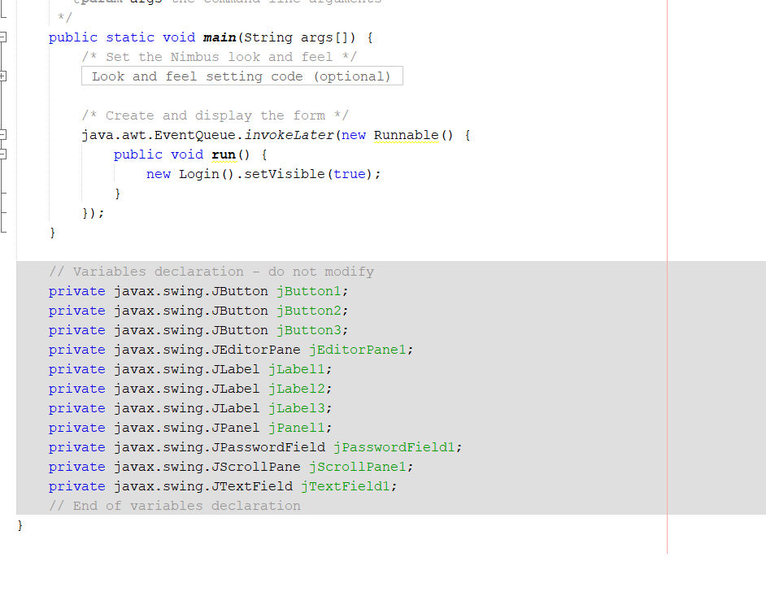
Forgot.java
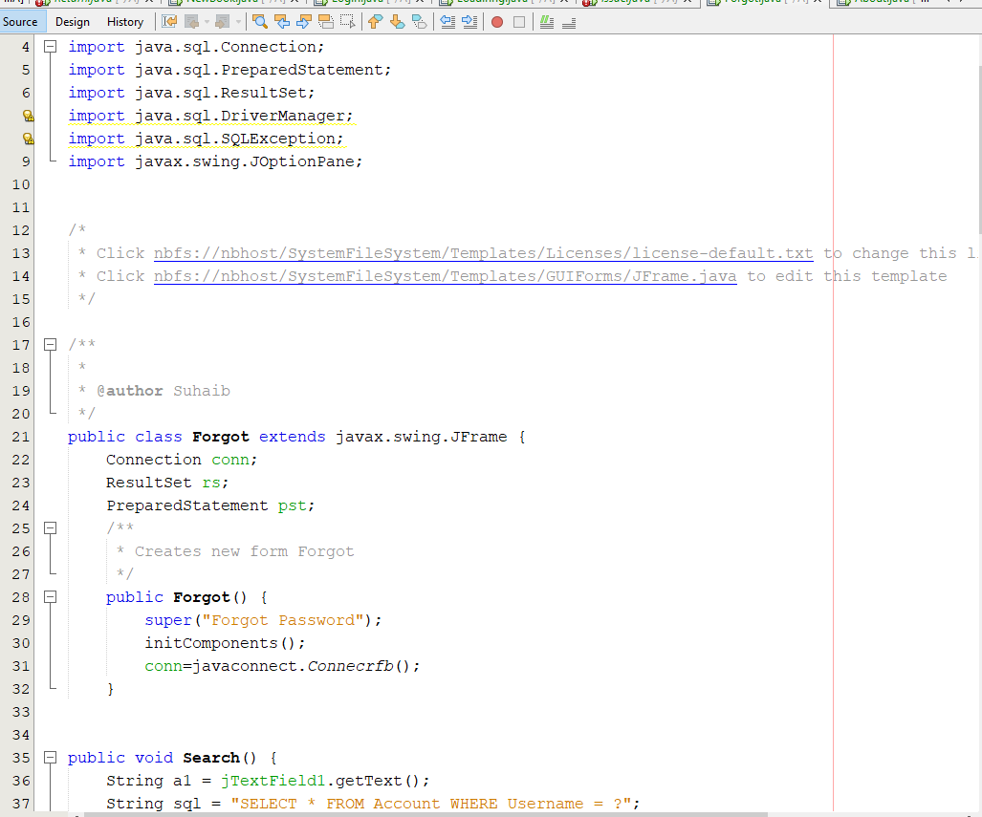
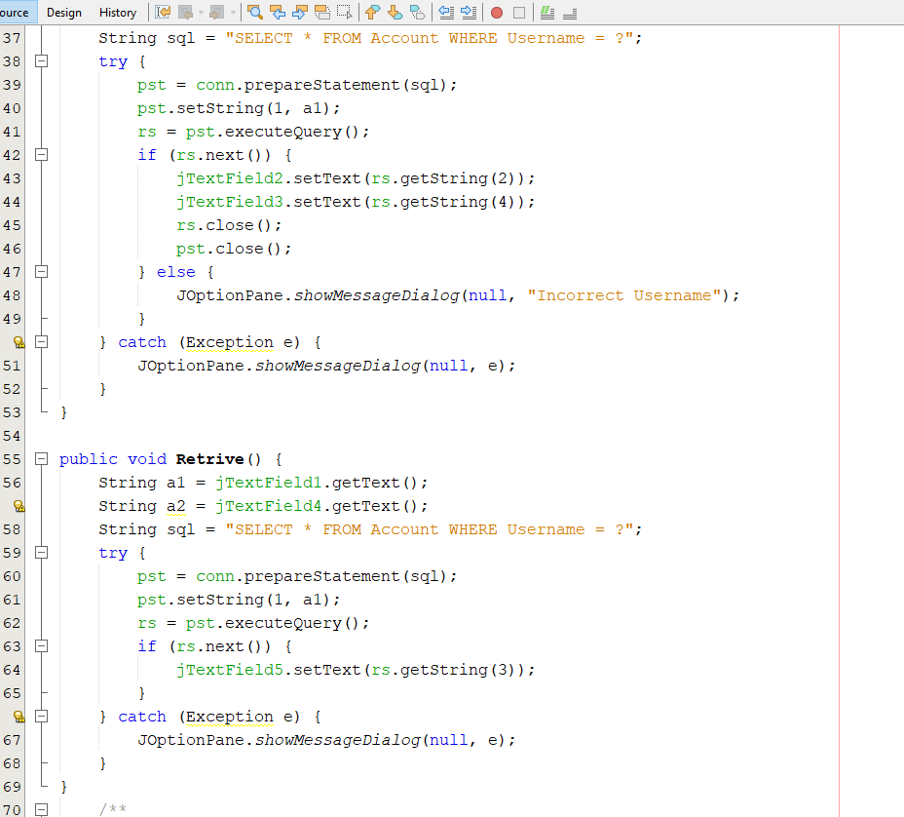
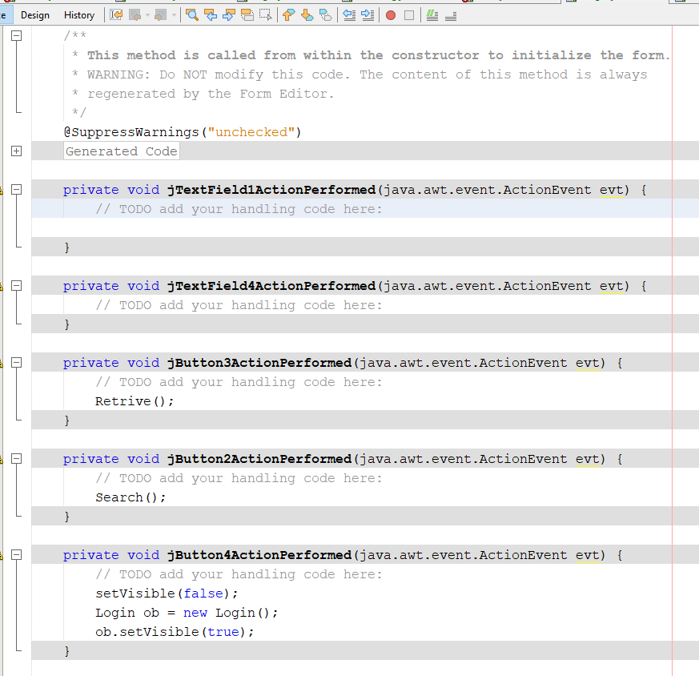
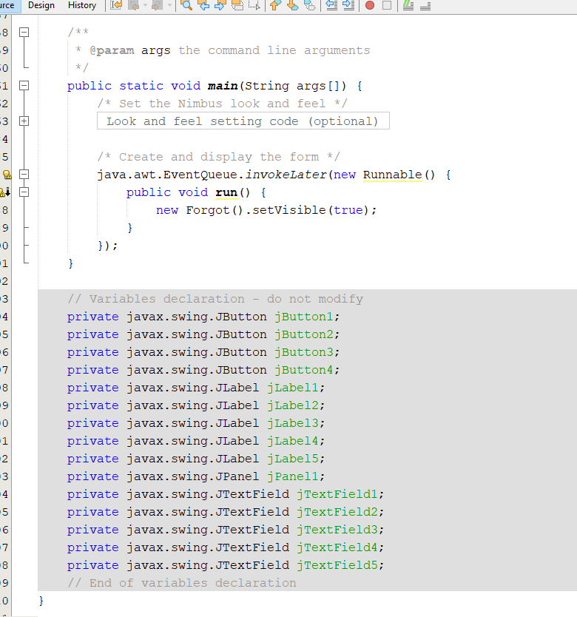
Signup.java
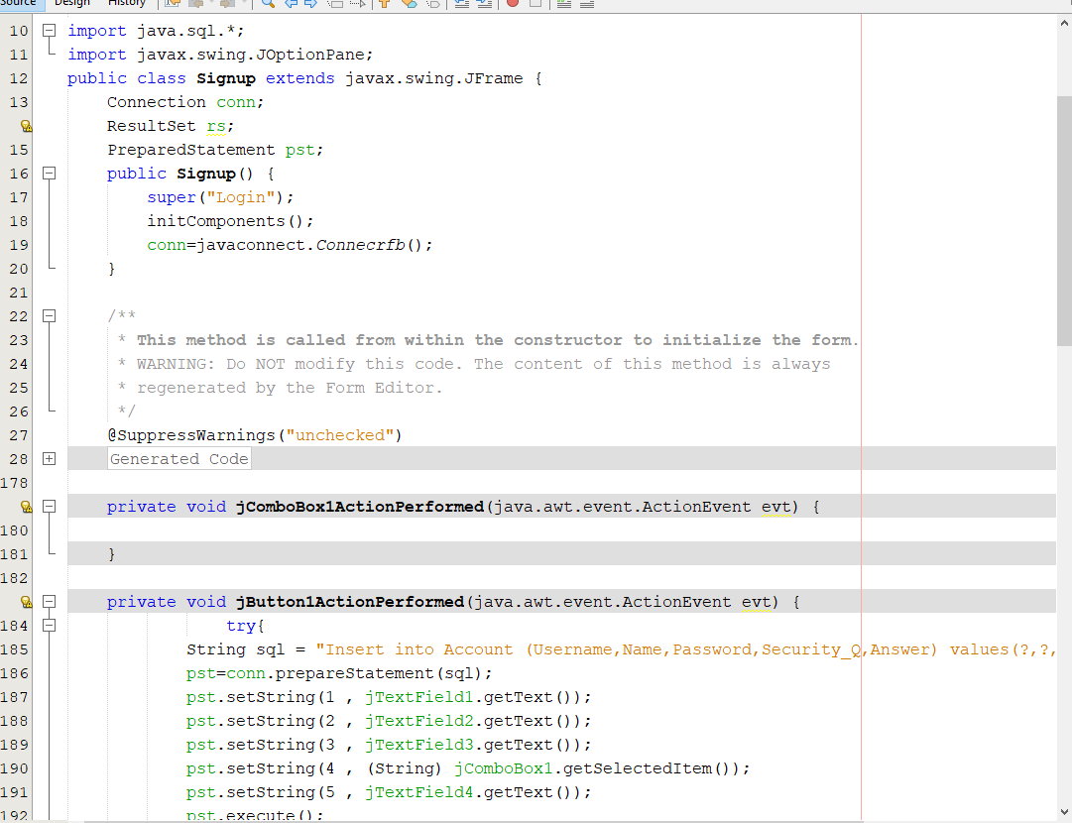
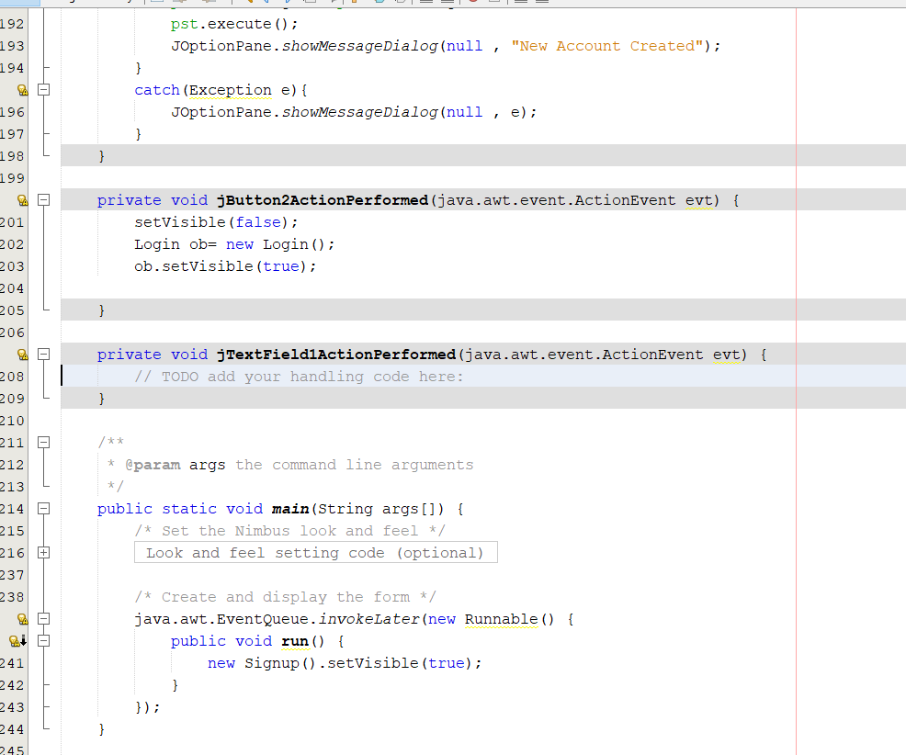
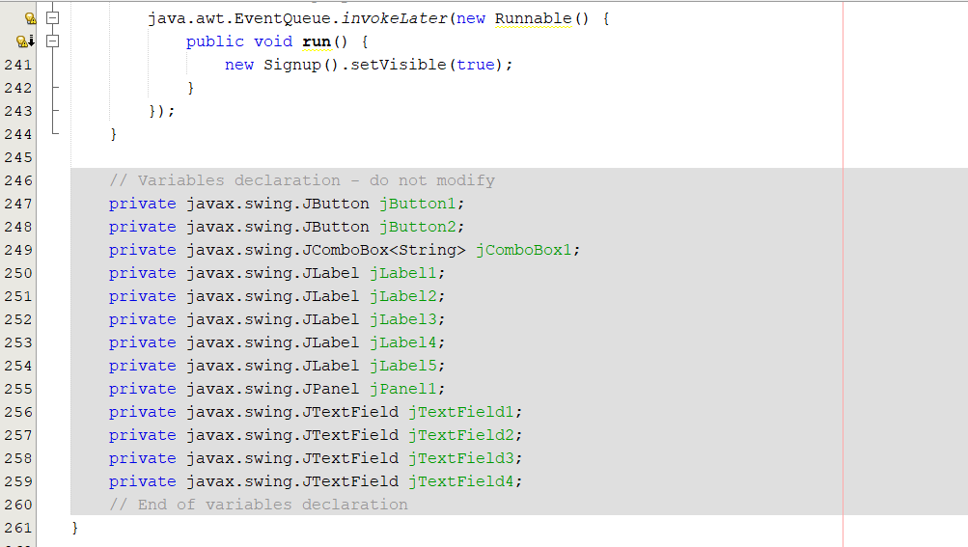
Home.java
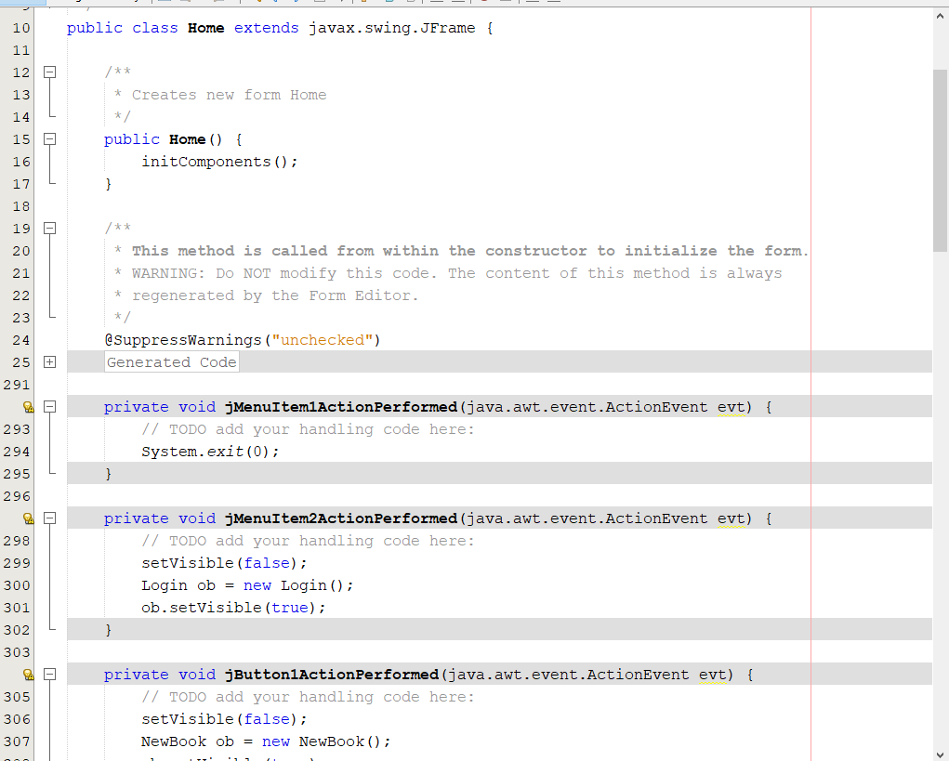
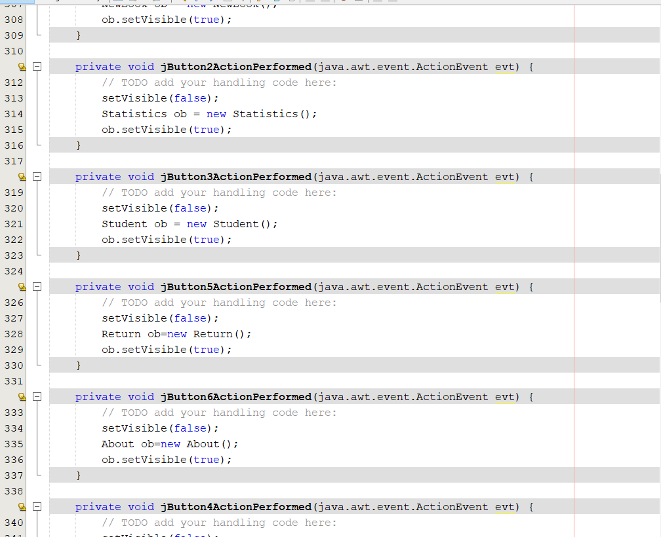
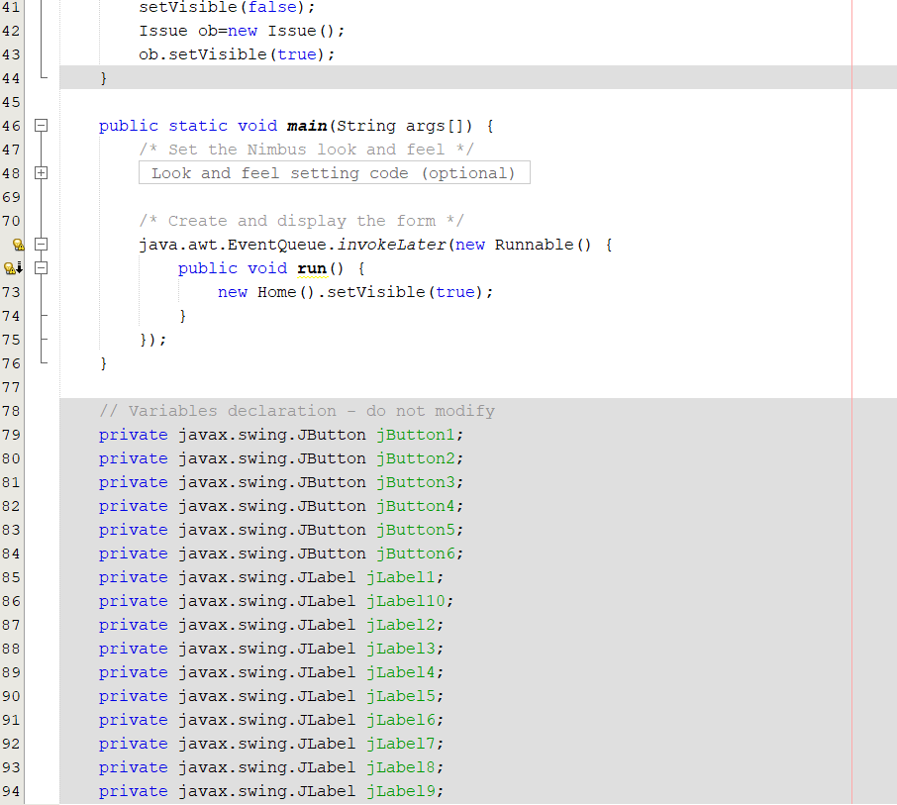
Student.java
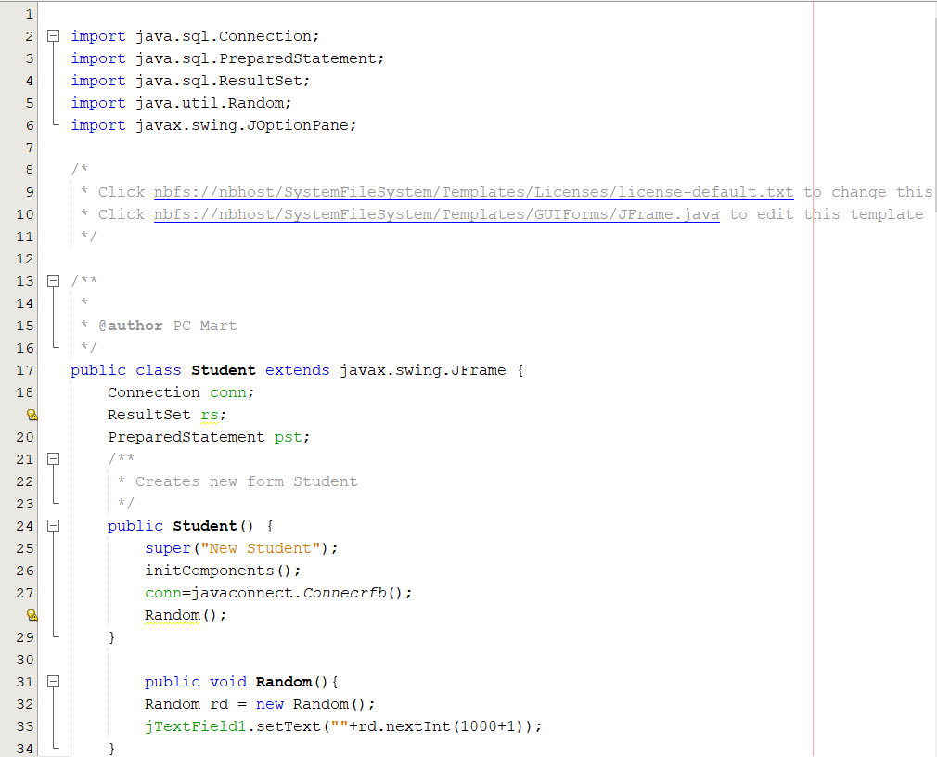
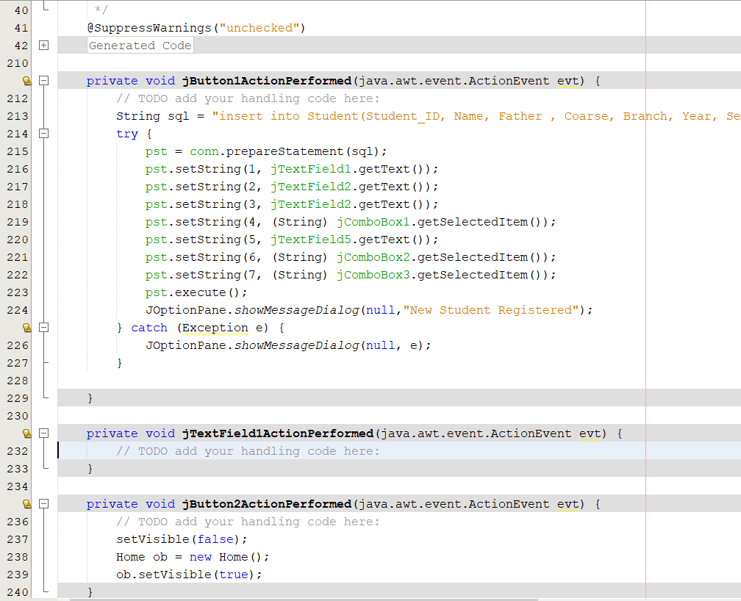
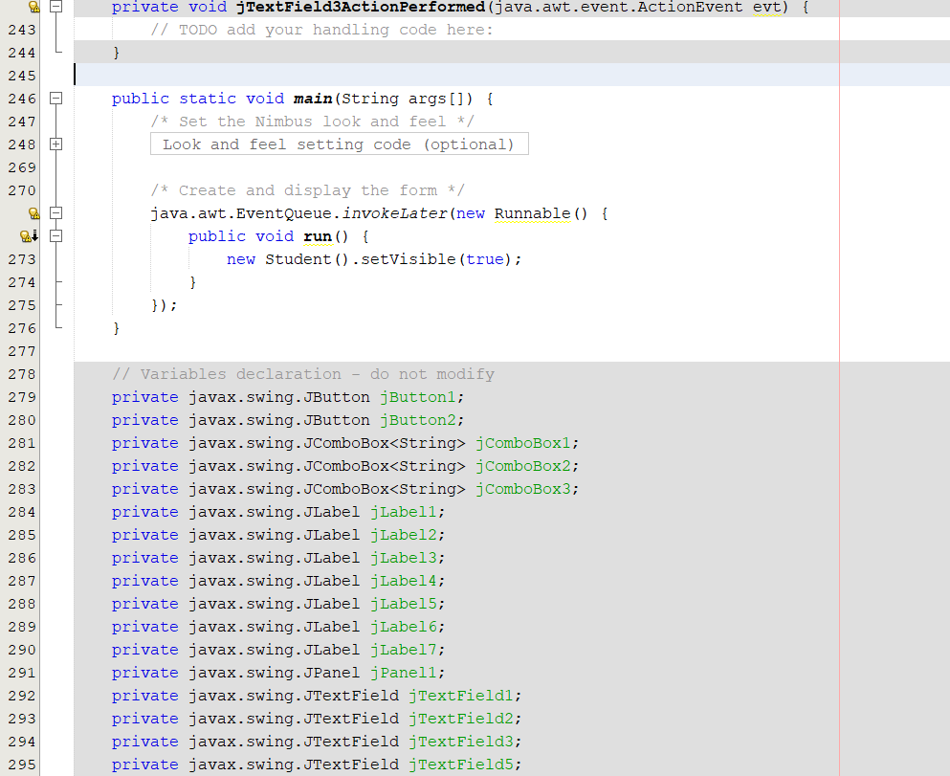
Statistics.java
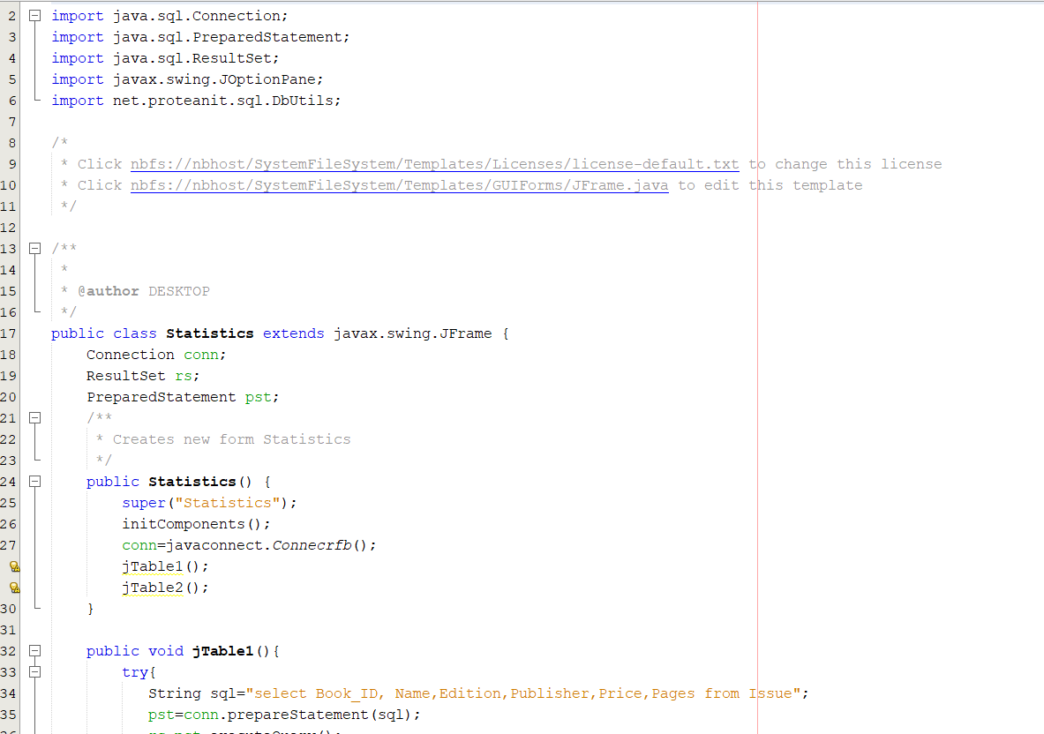
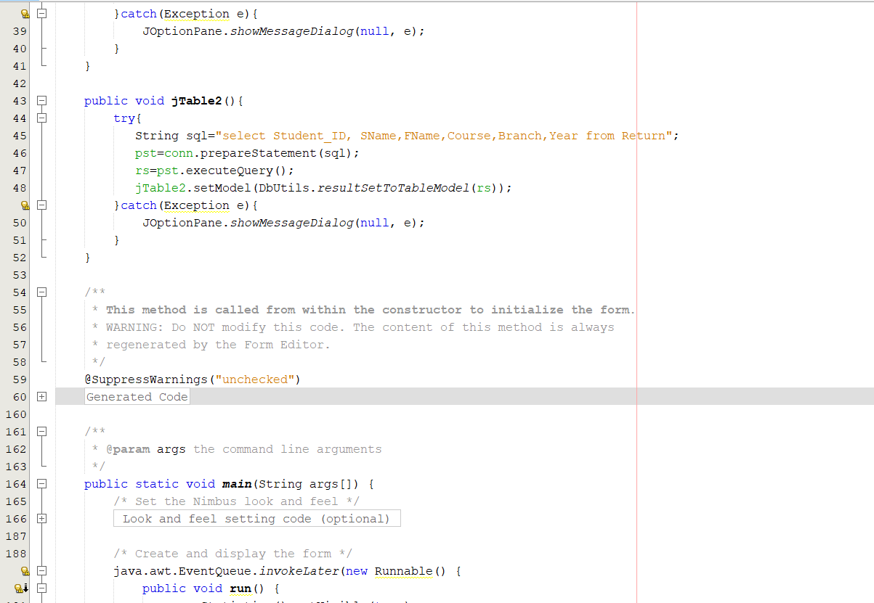
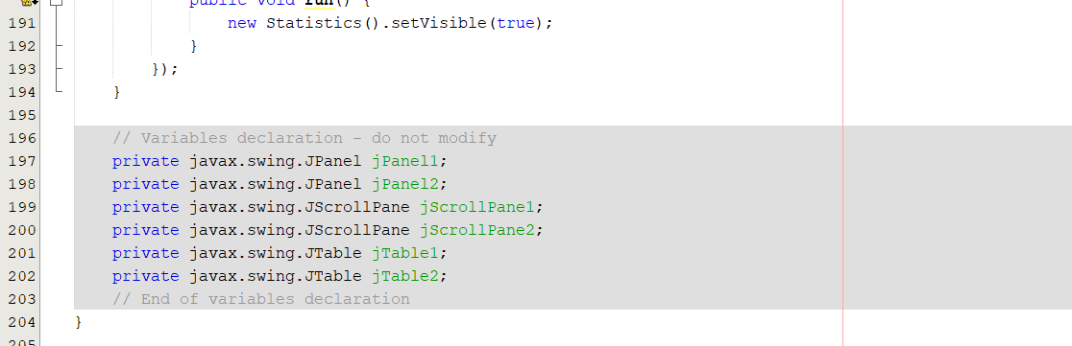
New Book.java
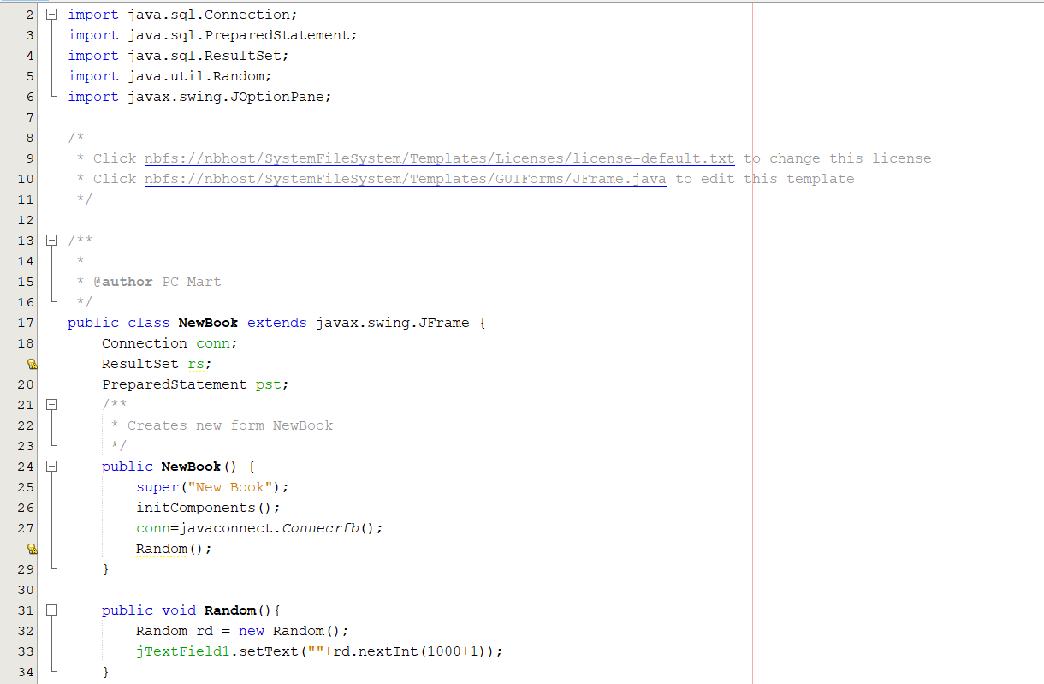
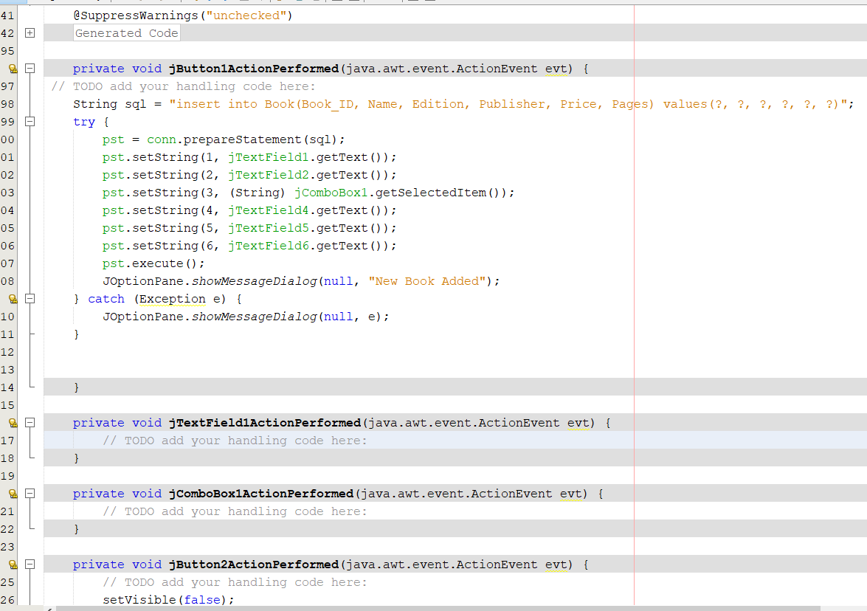
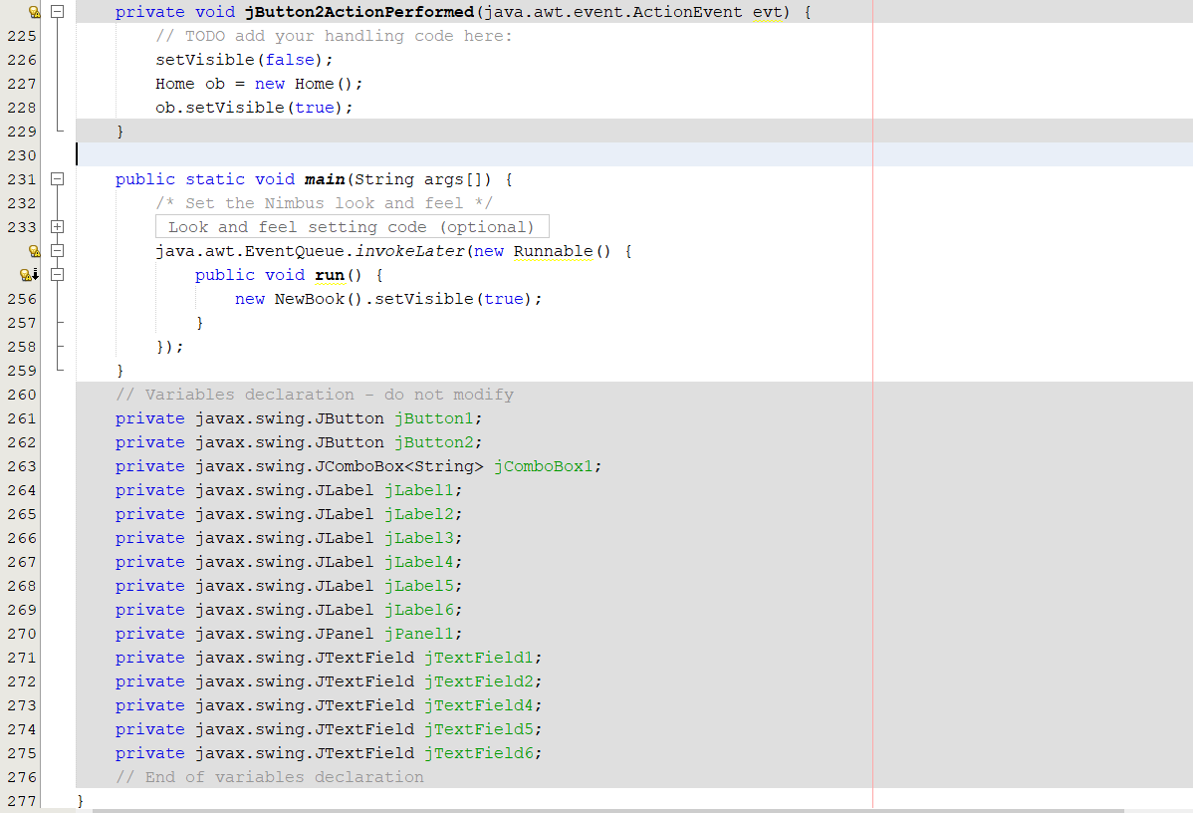
Return.java
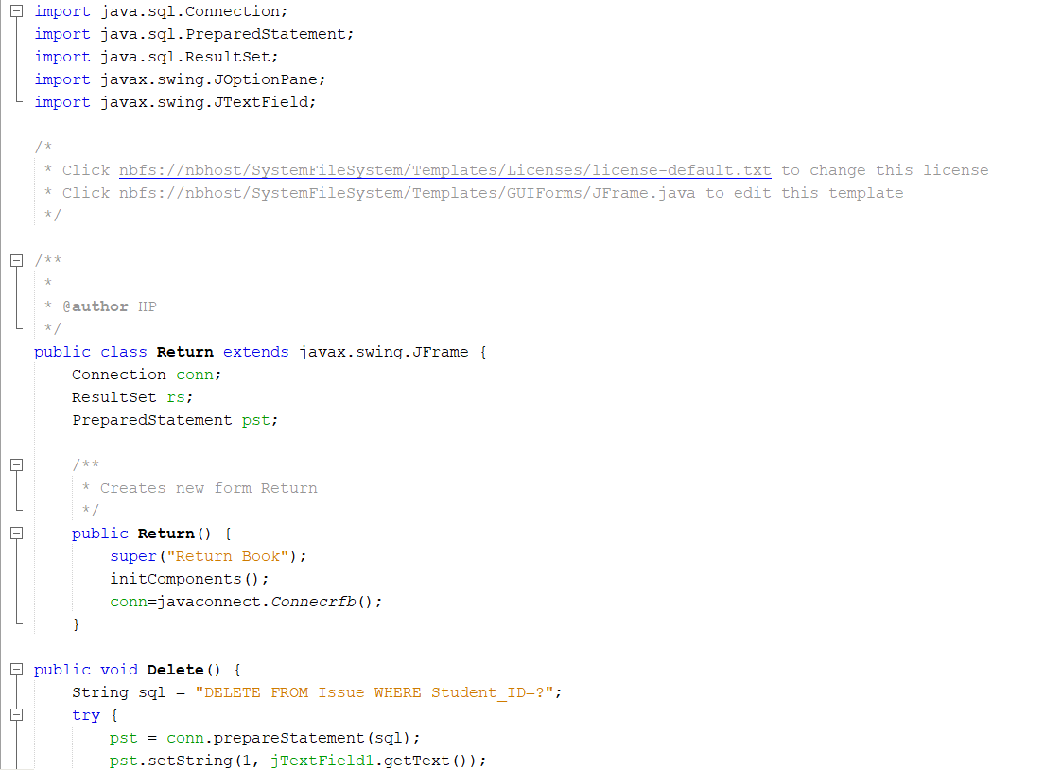
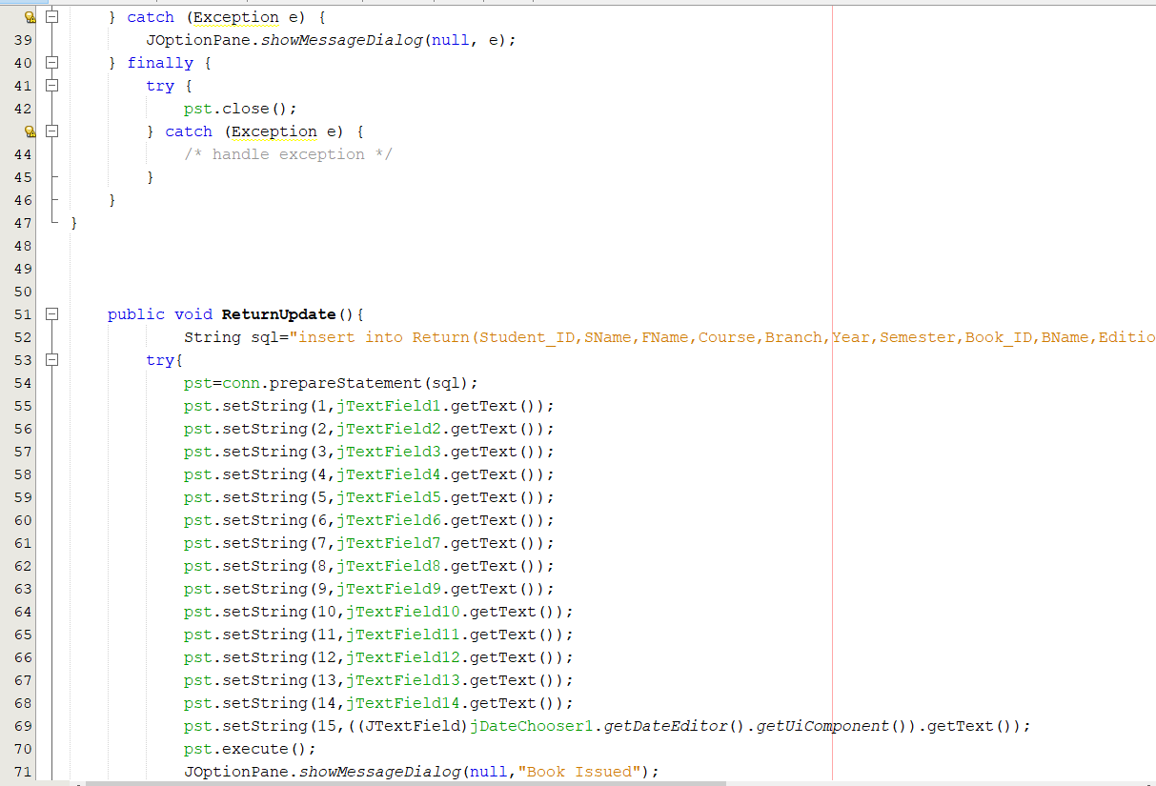

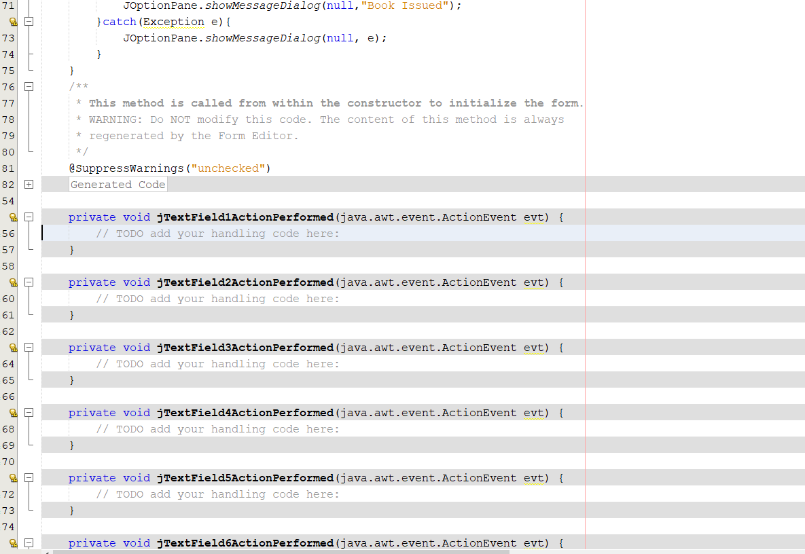
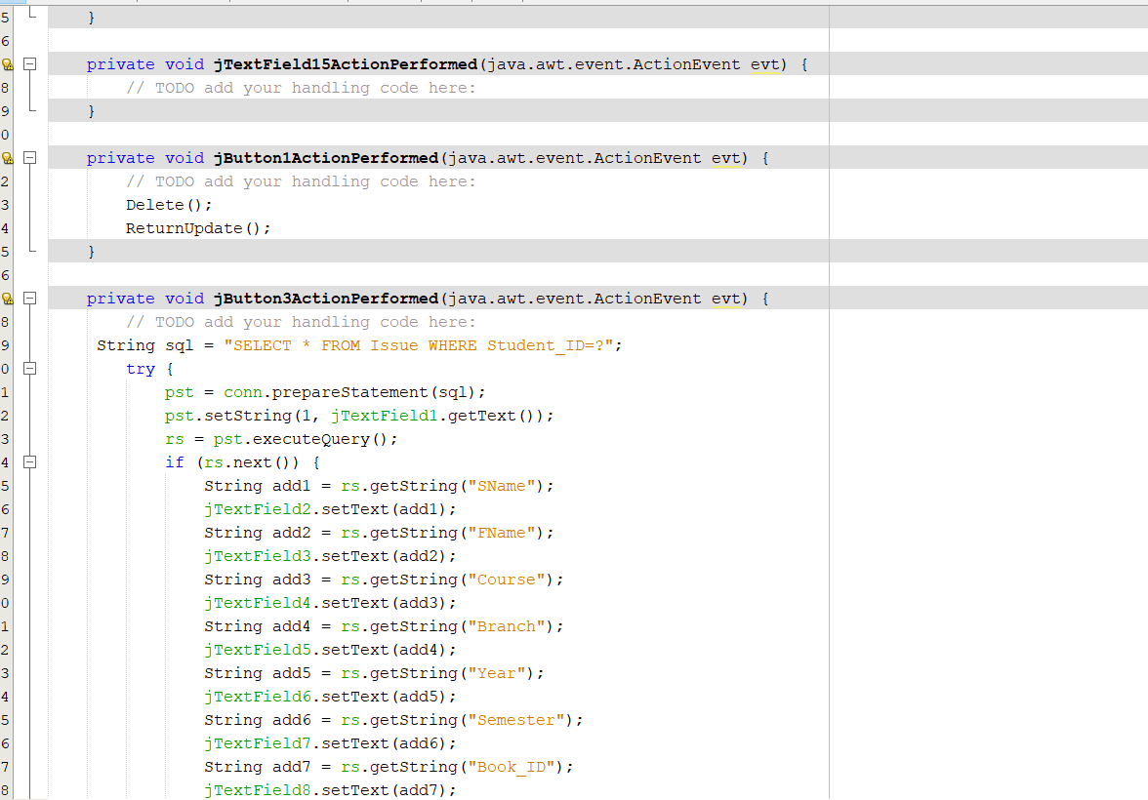
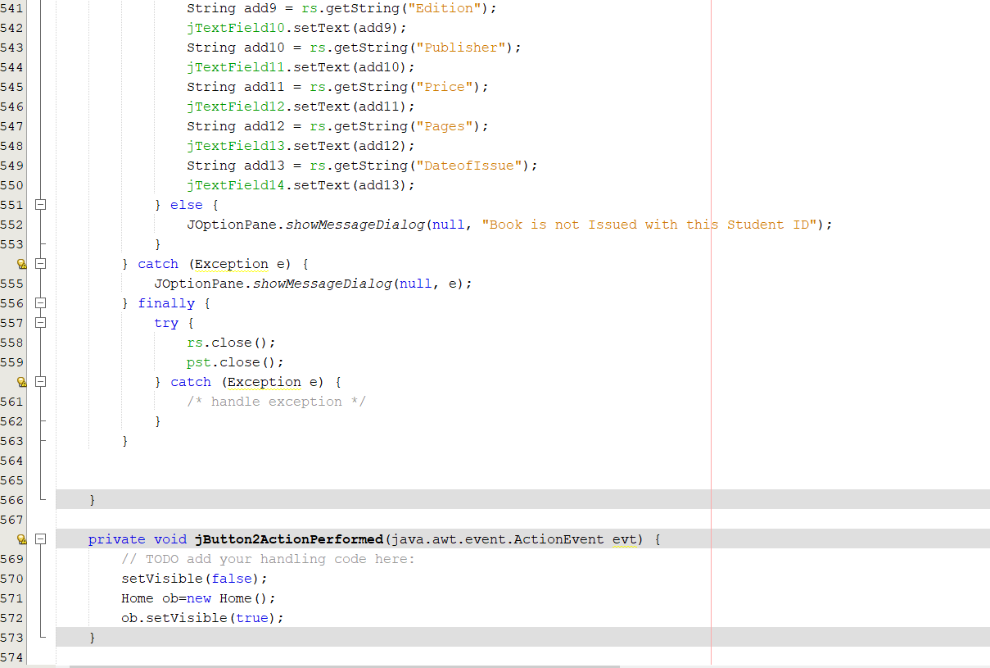
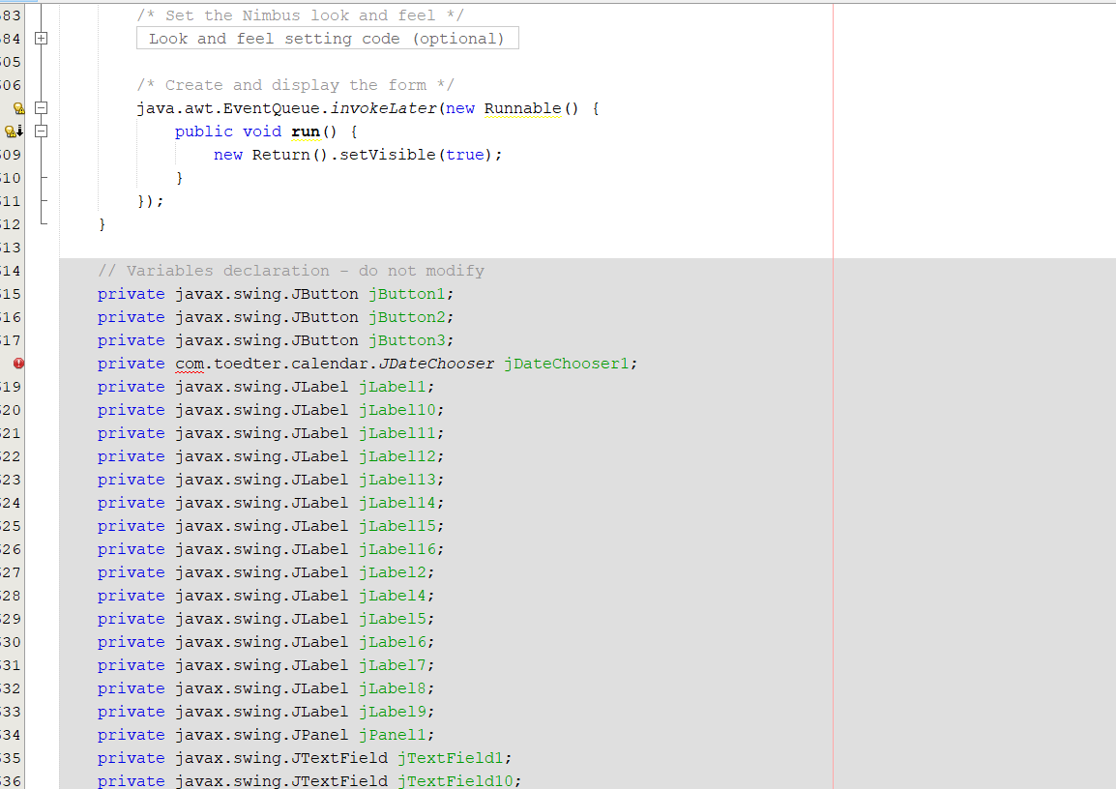

About.java
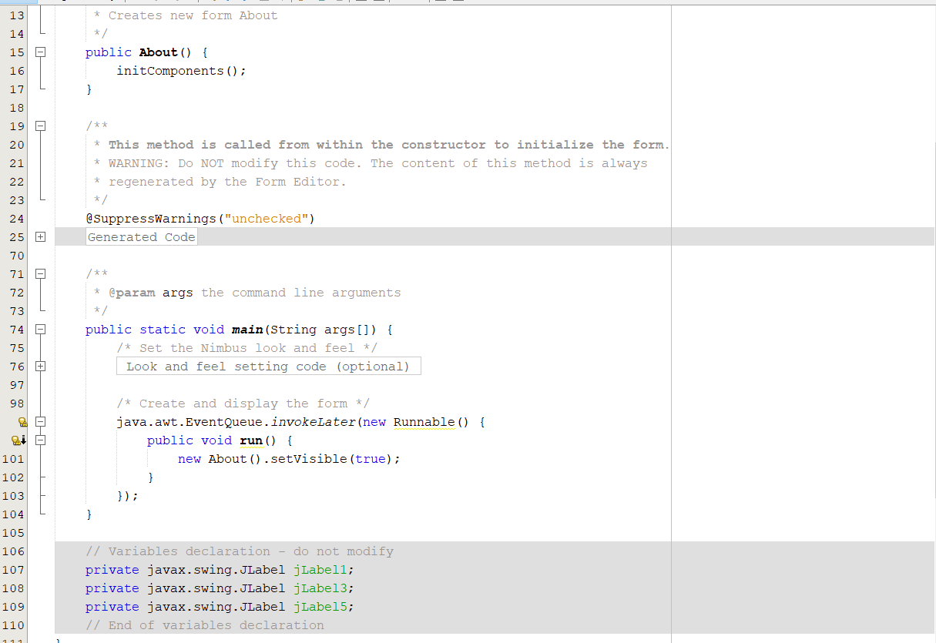
Issue,java
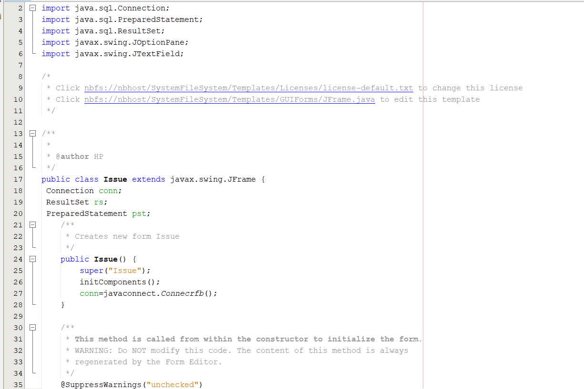
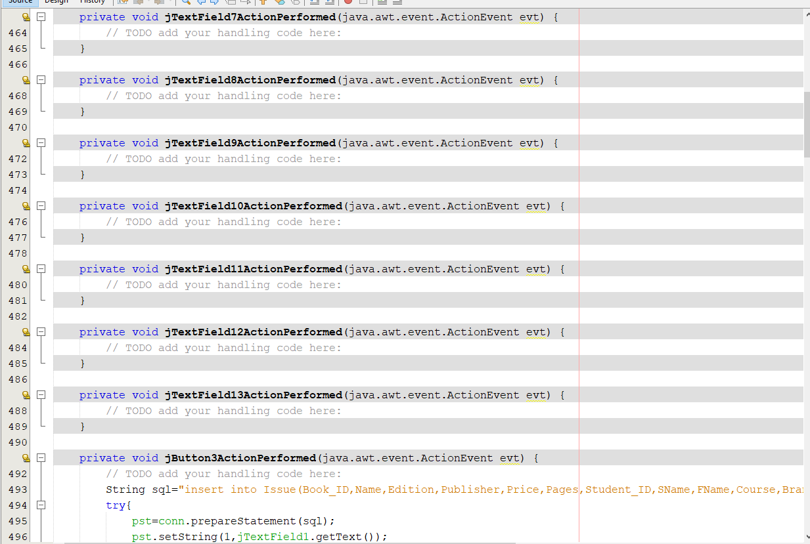
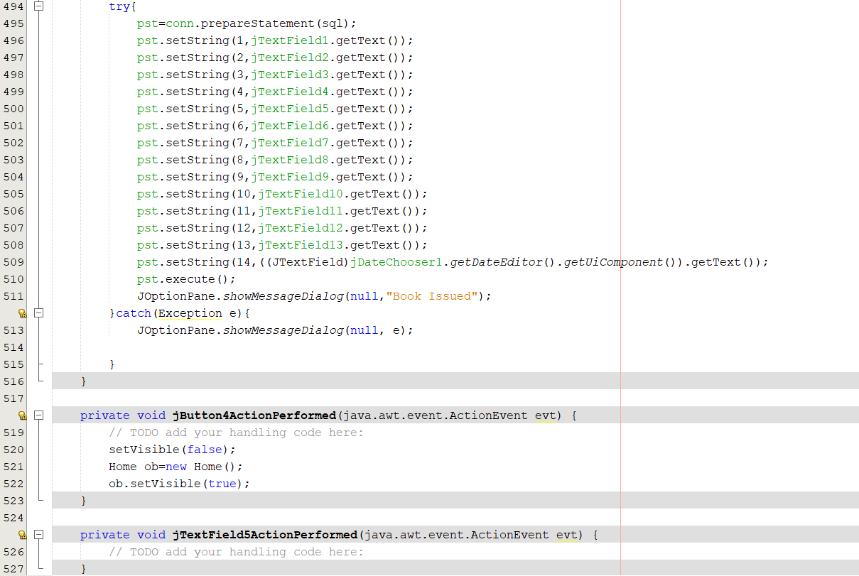
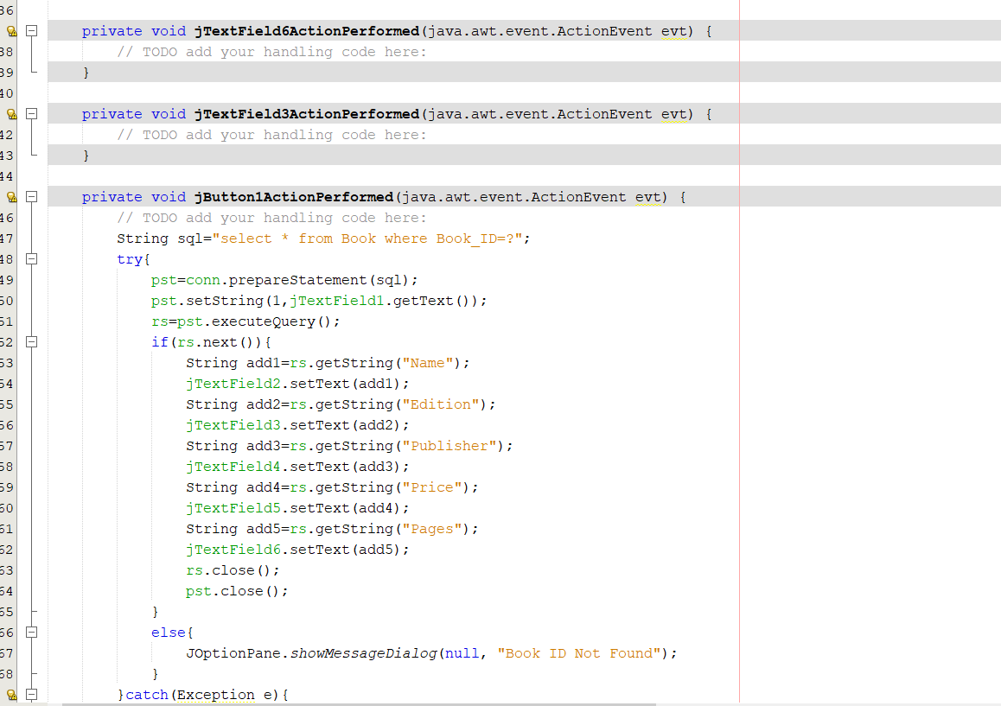
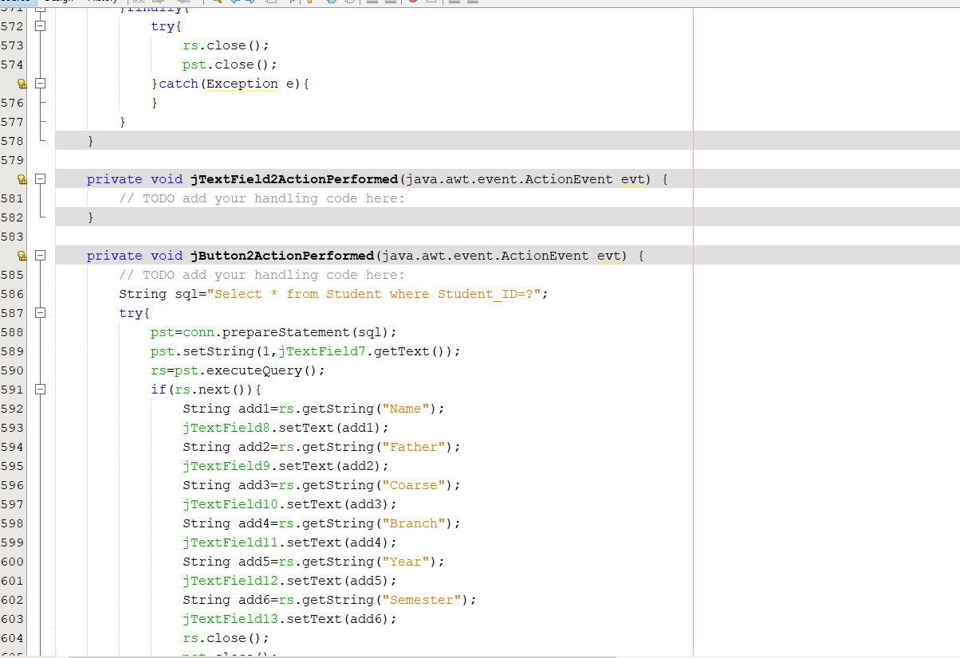
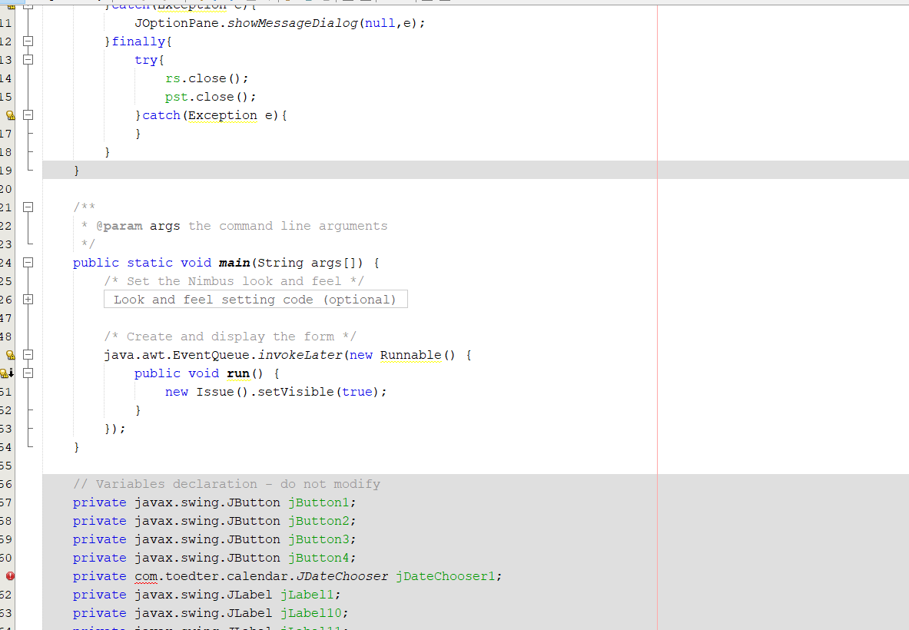

Loading.java
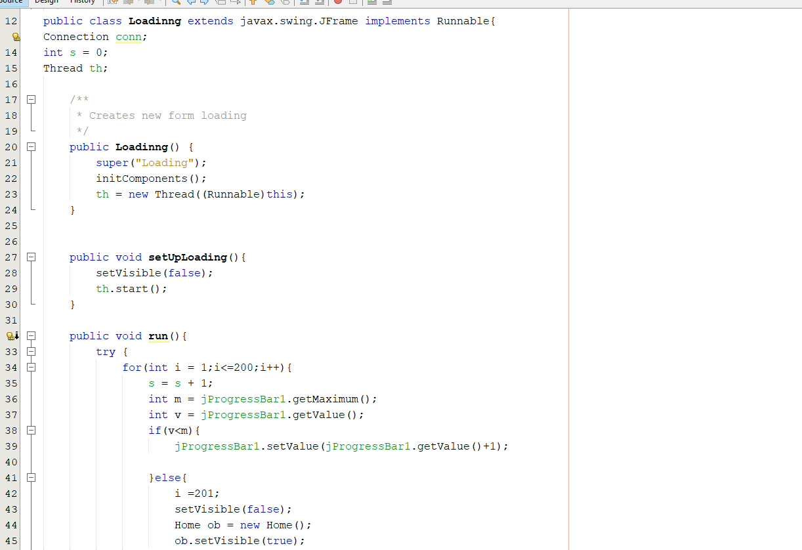
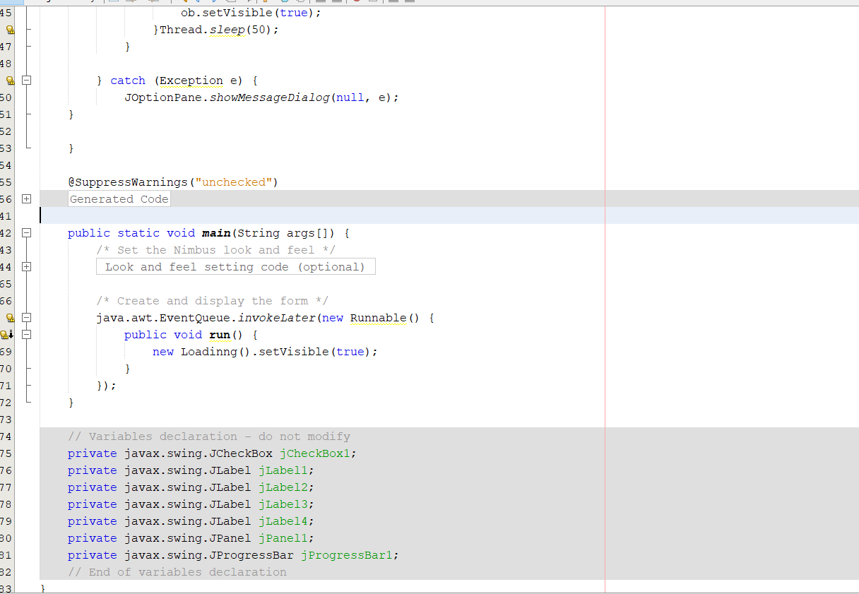
Javaconnect.java
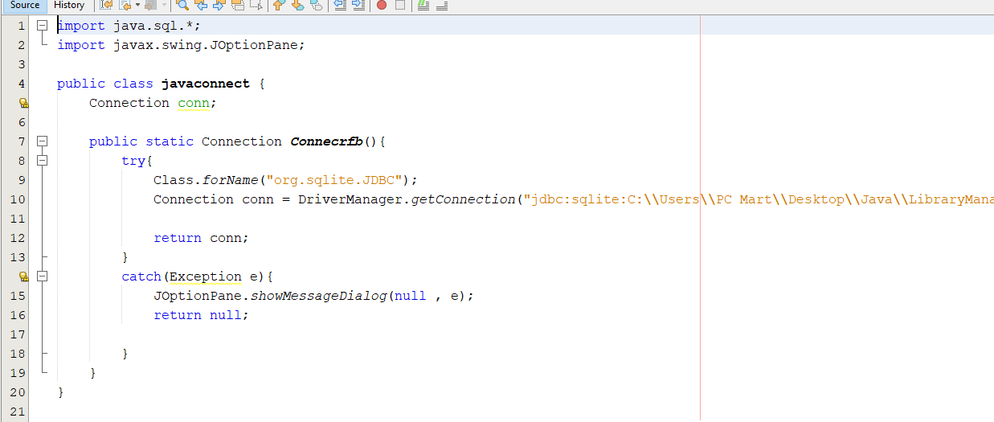

8. Complete Project Snapshot with Outputs :
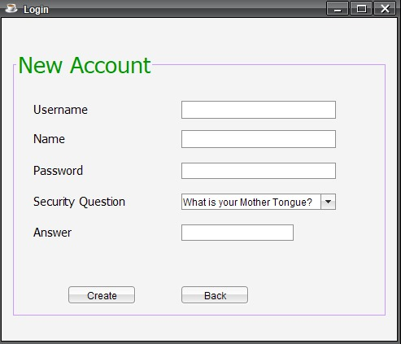
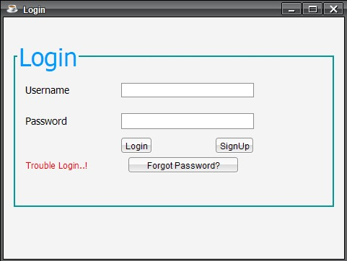
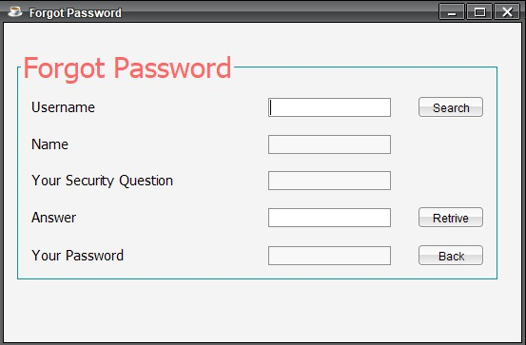

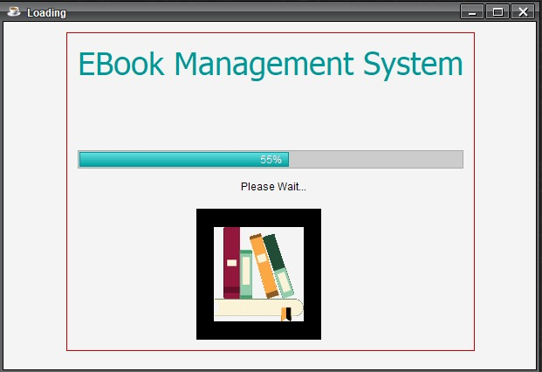
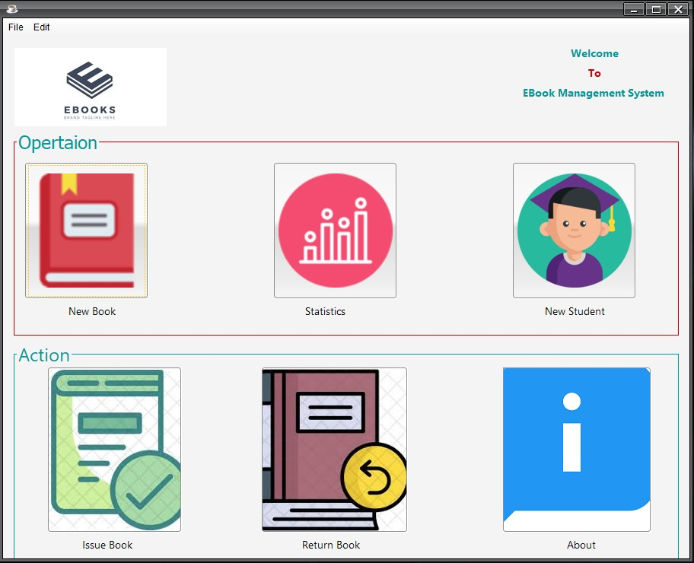
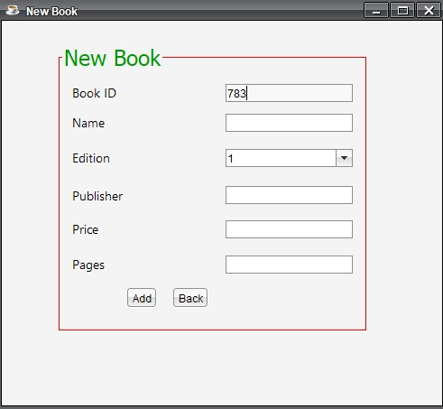
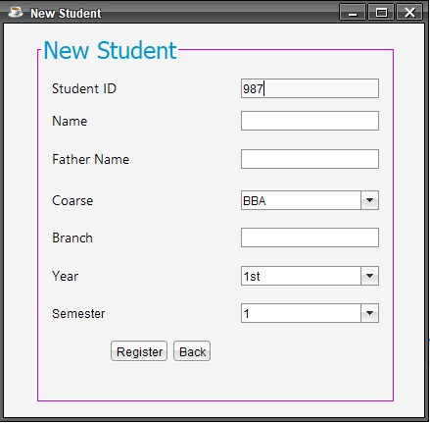
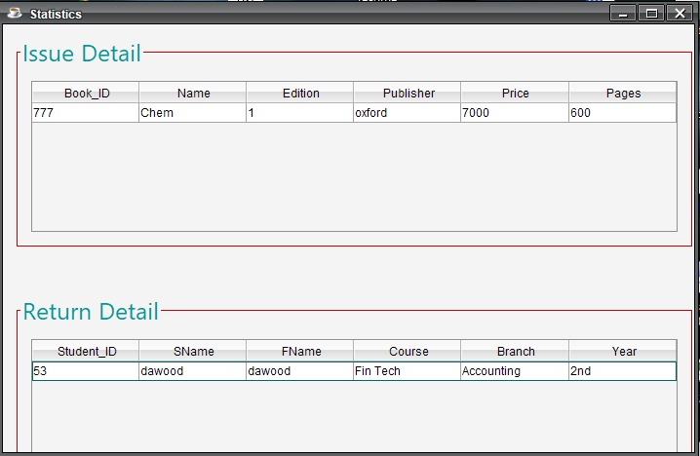
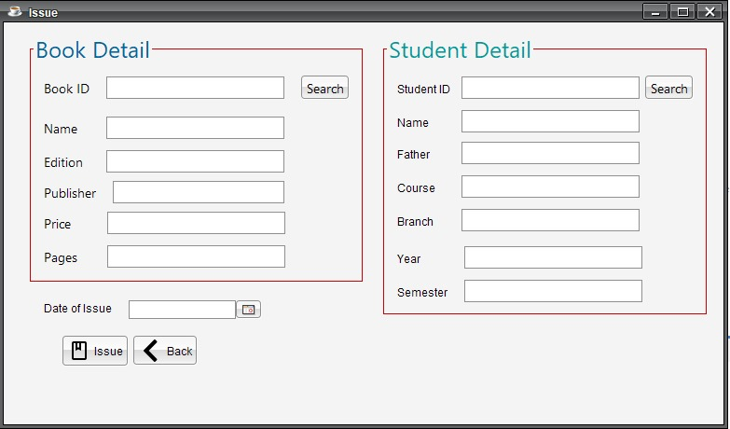
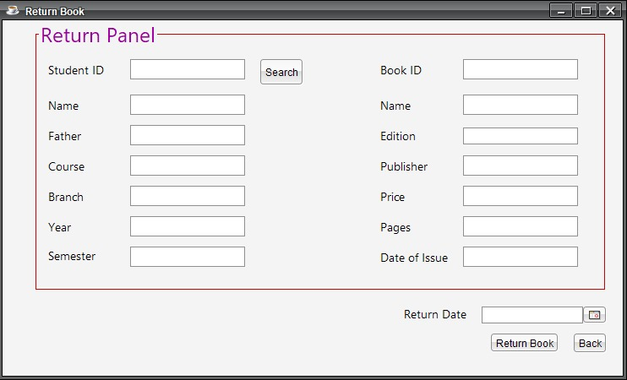
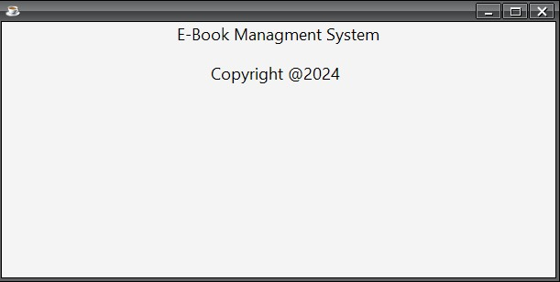
9. Flowchart Diagram :
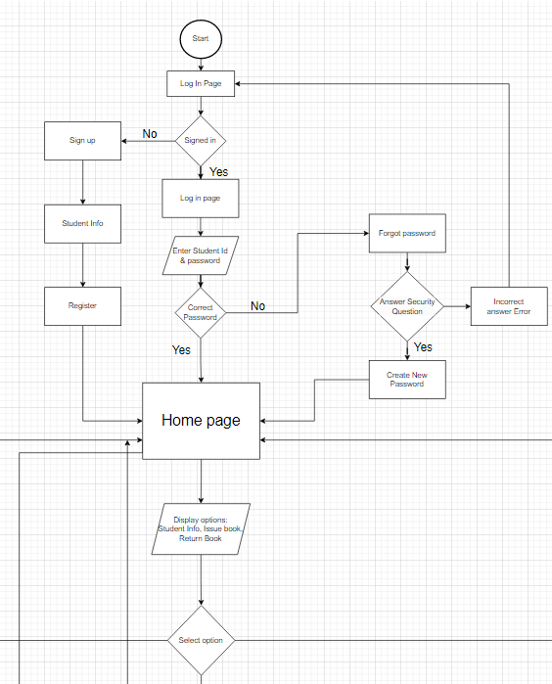

Home Page:

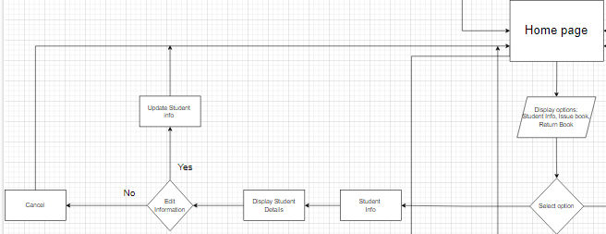
Student Info:

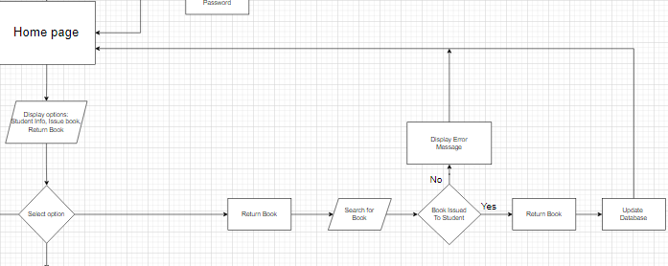

Return Book:

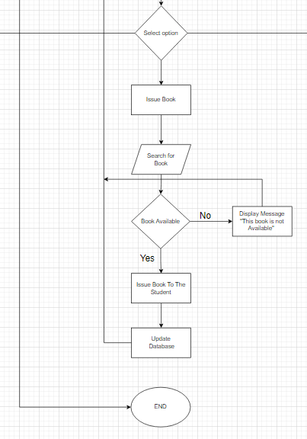

Issue Book:

10. Use Case Diagram :

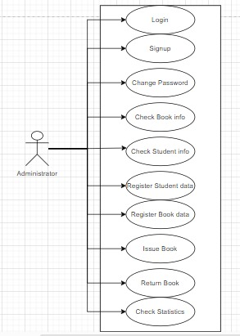

11. Class Diagram :
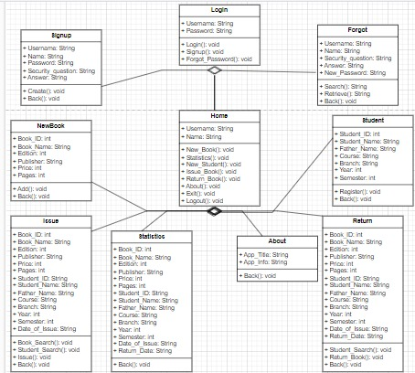

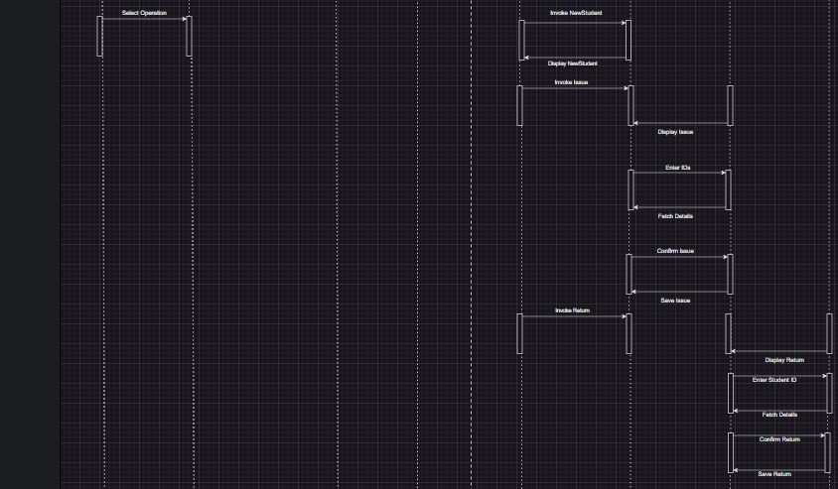
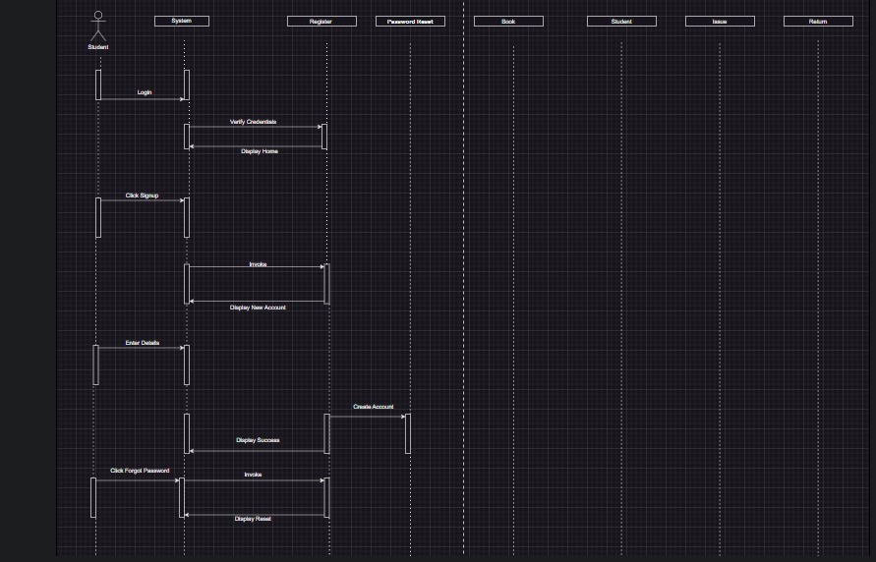
12. Sequence Diagram
13. Entity Relationship Diagram :
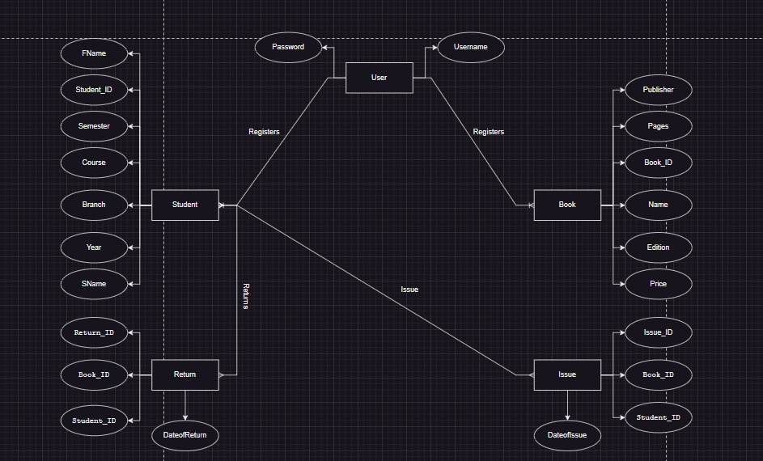

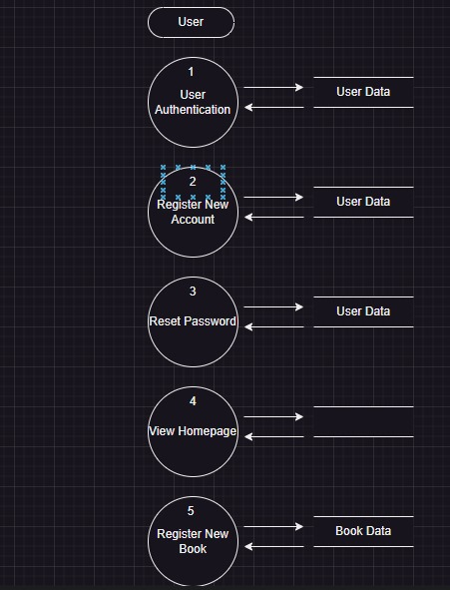
14. Data Flow Diagram :

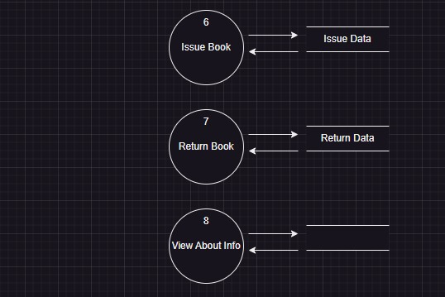

15. Conclusion :
The eBook Management System project aims to revolutionize the traditional management of educational resources, making it more efficient and error-free. By utilizing Java Swing for the GUI, the system ensures a seamless experience for both students and staff, ultimately leading to enhanced accessibility and operational efficiency.

16. References :
- Java Documentation: Comprehensive guides and references for the Java programming language.
- SQLite Documentation: Official documentation for SQLite, providing detailed information on database management and usage.
- Development Resources: Various online resources, tutorials, and forums were instrumental in the development of this project.

